***… where the IMI/isolates come from?***

*Sample origination and selection*

Samples included in the current study are a subset of mammary quarter milk samples collected during a longitudinal, cross-sectional study of 10 certified organic dairy farms in VT carried out in Winter 2019-2020. Participating farms on average milked 58 cows, with a variety of breeds represented. Five farms housed cows in a tiestall facility with wood shavings, and 5 utilized a bedded pack system (3 actively managed for composting, 2 static). Three farm visits were completed at 8 farms, with 1 herd sampled twice and 1 herd sampled 4 times before interruption by the COVID-19 pandemic. On average, 33.6 days elapsed between sequential farm visits (median: 34; range: 27-43). From each herd, 35 lactating cows of varying parity in early- to mid-lactation were chosen at random to be repeatedly sampled for the duration of the study. Cows that were unable to be sampled at a follow-up visit (dried off, left the herd) were replaced with another lactating cow in the herd dictated by convenience. At each farm visit, duplicate quarter milk samples were aseptically collected from each lactating quarter immediately before milking for all enrolled cows. Samples were kept on ice in a cooler during transport until stored at −20°C in the laboratory, where an aliquot was frozen for SCC measurement.

Duplicate, aseptic milk samples were collected

from each functional quarter of enrolled cows according

to NMC guidelines (NMC, 2017). Briefly, after milking

staff performed their usual pre-milking teat disinfection

routine, investigators, wearing clean disposable gloves,

scrubbed teat ends with 70% isopropyl alcohol-soaked

gauze swabs, discarded 3 squirts of foremilk, and

sampled approximately 20 to 30 mL of milk into sterile

60-mL vials. Samples were immediately chilled on ice.

*Aerobic culture of milk samples*

Standard aerobic bacteriological culture of milk samples was performed in duplicate within 24 hours of collection to identify the intramammary infection status of each quarter sampled. After being homogenized by gentle inversion, trypticase soy agar plates with 5% sheep blood were inoculated with one loopful (approximately 10 μL) of milk using disposable plastic inoculating loops. Plates were then incubated in aerobic conditions at 37°C before being read at approximately 48 hrs. A quarter was considered positive for an IMI when greater than or equal to 1 CFU (100 CFU/mL) of a particular isolate was identified with the same morphology for both duplicate samples (interpretation in series). A quarter was considered negative when there was no significant growth on either duplicate plate (≤2 CFU on each plate; if ≤2 CFU on both duplicates, morphology of isolates on each plate distinct from one another). Interpretation of duplicate quartermilk samples in series results in decreased sensitivity but higher specifity for identifying NASM intramammary infections, as compared to a single sample (Dohoo et al., 2011). This approach was chosen to maximize the specificity of culture to identify quarters as positive for a NASM IMI (i.e., minimize false positives), as collection of a large number of samples in the field under time pressure and occasionally with minimally trained personnel resulted in a moderately high rate of contamination (13%). Samples were classified as contaminated if more than 2 different morphologically-distinct isolates grew on a plate.

*SCC measurement*

Aliquots of frozen quartermilk samples were sent to the Vermont State Agricultural and Environmental Laboratory for determination of quarter-level somatic cell count using flow cytometry (Somacount FC, Bentley Instruments).

*Speciation of bacterial isolates*

Isolates deemed to be causing IMI were selected and grown in isolation on blood agar, and standard benchtop biochemical tests were done to presumptively identify bacteria following NMC procedure guidelines (Adkins et al., 2017).

Isolates were then preserved in tryptic soy broth with a final concentration of 15% glycerol in cryovials, and stored at -80°C.

* + All isolates collected were then sent for identification to the species level using MALDI-TOF (Dr. Pamela Adkins, U. Missouri).
  + Agnetis vs. hyicus; *tuf*; cut-off used
* subcultured on blood agar
* (Columbia agar with 5% sheep blood, Oxoid)
* The isolates identified as Staphylococcus spp.
* were stored at −80°C until further analysis.

All isolates collected were then sent to the Adkins Lab (U. Missouri College of Veterinary Medicine) for identification using a MALDI-TOF mass spectrometer (Microflex; Bruker Daltonics Inc., Billerica, MA). The peaks produced by each isolate were analyzed by the MALDI-TOF Biotyper reference library, and the confidence level for each identification reported by the software was used in the following manner: >2.0, species level identification recorded; 1.8–2, genus level identification recorded; and <1.8, MALDI-TOF identification not recorded.

All isolates collected were then sent to the Adkins Lab (U. Missouri College of Veterinary Medicine) for identification using a MALDI-TOF mass spectrometer (Microflex, Bruker Daltonics) using Flex Control software (Bruker Daltonics). The protocol for identifying bacterial isolates with MALDI-TOF mass spectrometry has been described previously (Adkins et al., 2022). Generated spectra were assigned a score based on similarity with spectra in the manufacturer’s database, as well as the University of Missouri laboratory custom database (Adkins et al., 2018). The confidence levels used for species identification were applied as previously described (Cameron et al., 2017), in which ≥1.7 was used for staphylococcal and mammaliicoccal species-level identification and <1.7 was classified as inconclusive. Suspect NASM isolates unable to be identified to the species level and those identified as *Staphylococcus agnetis* or *Staphylococcus hyicus* by MALDI-TOF were speciated using *tuf* gene sequences, using the recommended cut-off of ≥ 98.0% identity with > 0.8% separation between species (Hwang et al., 2011).

* DHIA and records data
  + DIM and parity were obtained from DHIA records for 9/10 herds
  + DIM and parity for last herd was obtained from producer who kept meticulous written records

*Selection and description of data set*

The initial data set included 3,331 quarter observations where the intramammary infection status of a quarter could be determined. Quarters were then selected that: 1) had an intramammary infection due to any *Staphylococcus* species (in pure culture) with ≥ 5 associated observations *or* was culture negative; 2) was collected from a cow ≤ 305 days in milk at time of observation; 3) had an associated quarter-level somatic cell count measurement (Figure XX)*.* The final data set of 2,260 observations came from 1,272 quarters of 360 cows across the 10 herds included in the field study. The mean (median; range) number of cows included per herd was 36 (36; 34-39), whereas the number of quarters sampled per cow was 3.5 (2; 1-4). The mean number of observations per quarter included was 2.1 (2; 1-4). The average time elapsed between sequential observations of a quarter was 37.1 days (median: 34.5; SD: 11.6), with an overall range of 27-96 days.

***Data analysis:***

Data analysis was carried out using the R Statistical Programming Environment.

Somatic cell counts associated with quarters identified to have single-pathogen intramammary infections with a given Staphylococcal species were compared with the SCC of all culture negative quarters. Quarters that had an intramammary infection due to more than one pathogen (mixed infection) were discluded from analyses. Raw quarter-level somatic cell count was converted to somatic cell score [log2(raw quarter somatic cell count/1000) + 3] in order to address the non-normal distribution of of SCC data.

A linear mixed-effects model was fitted to the data set in order to explore the effect of different Staphylococcal species on quarter SCC, using the “lme” function of the “nlme” package (R Statistical Programming Environment, R Core Team, 2024). In this model, the somatic cell score for each quarter observation was the outcome variable, and Staphylococcal species causing IMI (with culture negative quarters as the reference value) was the fixed predictor variable. The number of days in milk at time of sampling was included in the fixed part of the model to adjust the estimates of the Staph. species and quarter SCC association for confounding by this variable. The hierarchical structure of the data was addressed by fitting random intercepts for quarter, cow, and herd (observations nested within quarter, quarters nested within cow, and cow within herd). Samples collected at different time points for a given quarter were considered repeated measurements, and a spatial exponential correlation structure was used to account for the correlation between multiple milk samples collected from the same quarter. Best way to say we are essentially ignoring the time between observations (~30 days), as it’s so short?

Actually put model in:

IMI and DIM (as a 3 degrees polynomial term)

SCS*ijkl* = β0 + β1 Staph. species*ijkl* + β2DIM*ijkl* + β3DIM*ijkl*2 + β4DIM*ijkl*3 + v*l* + u*kl* + w*jkl* + e*ijkl*,

where SCS*ijkl* is the predicted somatic cell score for the *i*th sample of the *j*th quarter of the *k*th cow from the *l*th herd; β0 is the intercept; β1, β2, β3, and β4 are the regression coefficients for Staphylococcal species, DIM (centered on 200 DIM- don’t think we did this), DIM quadratic and cubic terms (to correct for the nonlinear relationship between DIM and SCS), respectively; and *vl*, *ukl*, *wjkl*, and *eijkl*are the herd random effect, cow random effect, quarter repeated effect, and sample error term, respectively (approximate normal distribution assumed).

* Linear mixed-effects model fit by REML (restricted maximum likelihood)
  + Random effects:
    - quarter within cow within herd
  + Fixed effects:
    - Third-degree polynomial with DIM
    - IMI status (no growth, staph. by species)
    - Interaction terms between IMI and DIM were not significant (P-value = 0.42). So, both IMI status and DIM affect SCS, but the effect of IMI status on SCS does not vary as function of DIM
  + Correlation structure:
    - spatial exponential correlation structure

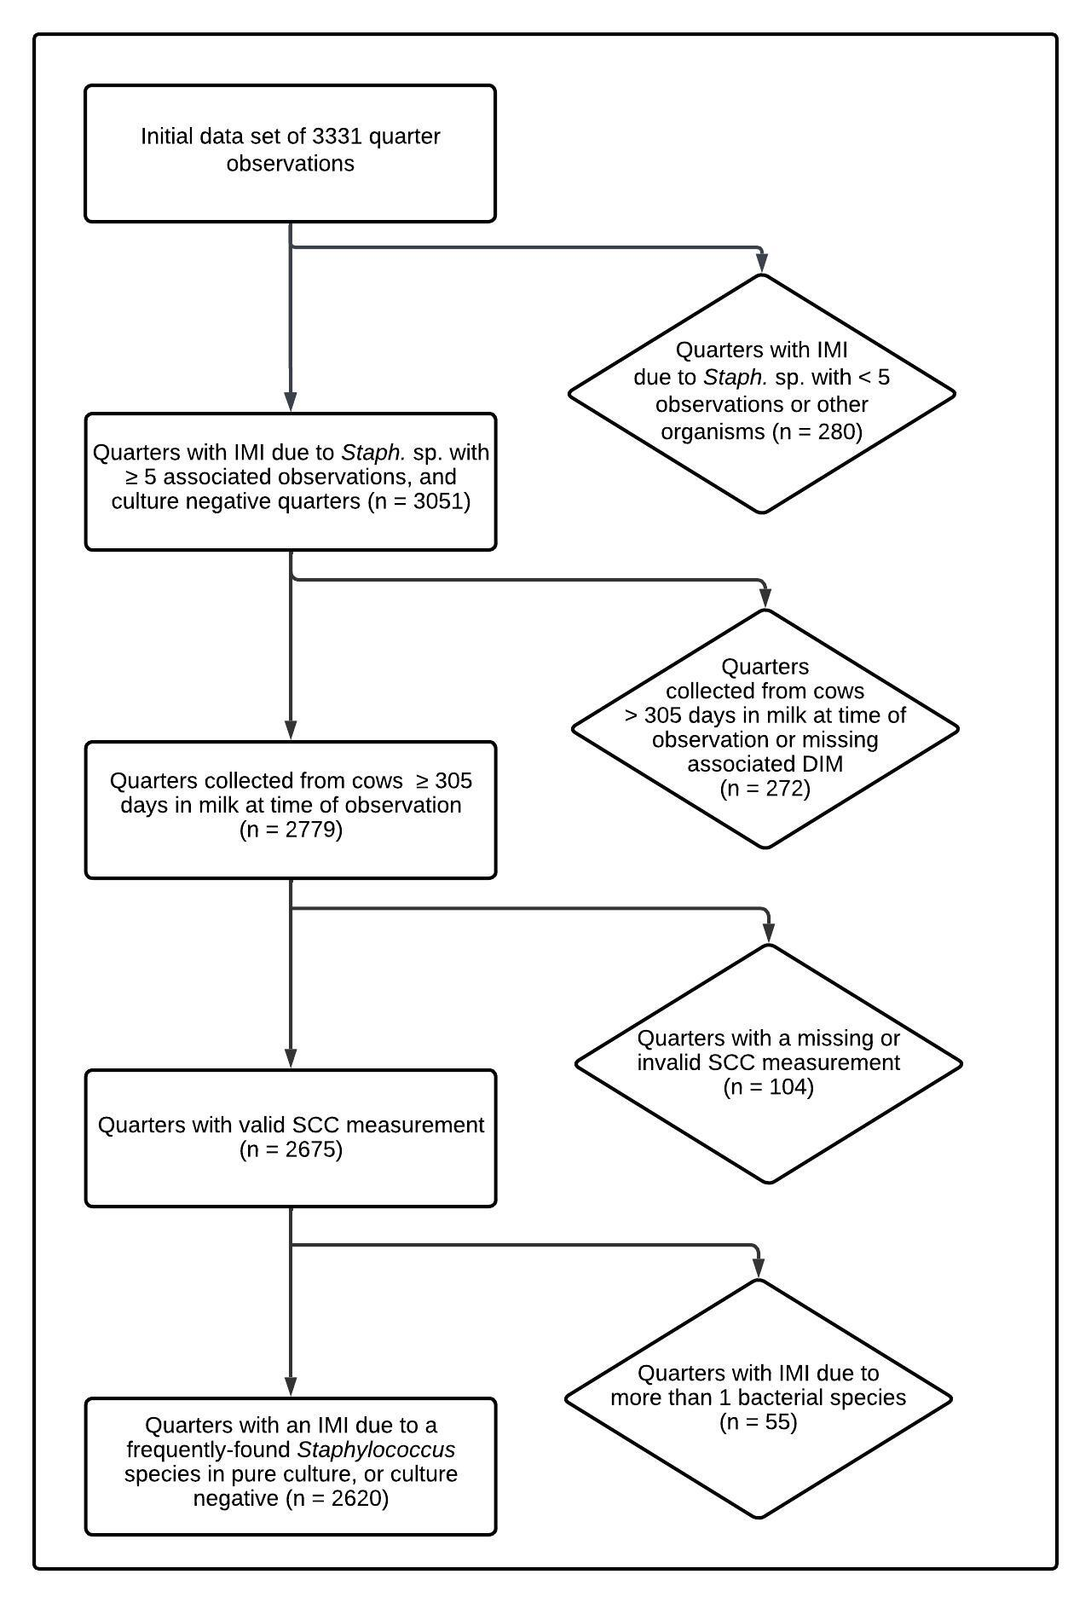

Figure XX.Flow diagram describing selection of final data set.

***Results:***

|  |  |  |  |
| --- | --- | --- | --- |
| Table XX. Final multivariable model describing the effect of intramammary infection with frequently-isolated *Staphylococcus* species on quarter somatic cell score, adjusted for days in milk at time of sampling. [Do I need to mention that DIM was included as a 3-degree polynomial term/If yes, how share this? Do all three levels of DIM coefficient and SE go into the table as well? Some of the p-values are crazy tiny – how far out with 0’s should we go? Do I need the asterisks?] | | | |
| *Staphylococcus* sp. | No. quarter observations | Coefficient estimate (SE) | *P*-value |
| Intercept | - | -0.03 (0.29) | 0.90 |
| No growth | 1972 | *Reference* | *Reference* |
| *S. agnetis* | 21 | 3.76 (0.45) | <0.00001* |
| *S. aureus* | 112 | 4.81 (0.22) | <0.00001* |
| *S. chromogenes* | 384 | 2.88 (0.12) | <0.00001* |
| *S. devriesei* | 15 | 1.62 (0.54) | 0.003* |
| *S. equorum* | 9 | 0.12 (0.48) | 0.81 |
| *S. haemolyticus* | 40 | 1.77 (0.31) | <0.00001* |
| *S. hyicus* | 6 | 3.23 (0.85) | 0.0001* |
| *S. simulans* | 35 | 3.11 (0.39) | <0.00001* |
| *S. warneri* | 15 | 5.18 (0.60) | <0.00001* |
| *S. xylosus* | 11 | 2.96 (0.62) | <0.00001* |
| Days in milk (1) | - | -0.003 (0.01) | 0.54 |
| Days in milk (2) | - | 0.00001 (0.00004) | 0.73 |
| Days in milk (3) | - | <0.00001 (<0.00001) | 0.53 |
| * Quarter somatic cell score differs from negative controls | | | |

|  |  |  |
| --- | --- | --- |
| Table XX. Estimated quarter somatic cell count by intramammary infection status at 91 days in milk (13 weeks) for frequently-isolated *Staphylococcus* species and culture-negative quarters. [which one we like better?] | | |
| *Staphylococcus* sp. | Estimated quarter somatic cell count (cells/mL) | 95% lower and upper confidence level (cells/mL) |
| No growth | 10,927 | 8,056 - 14,822 |
| *S. agnetis* | 148,437 | 69,021 - 319,232 |
| *S. aureus* | 307,101 | 197,323 - 477,951 |
| *S. chromogenes* | 80,376 | 56,942 - 113,454 |
| *S. devriesei* | 33,513 | 13,597 - 82,599 |
| *S. equorum* | 11,855 | 5,292 - 26,556 |
| *S. haemolyticus* | 37,333 | 21,217 - 65,688 |
| *S. hyicus* | 102,478 | 26,368 - 398,281 |
| *S. simulans* | 94,617 | 48,346 - 185,175 |
| *S. warneri* | 395,190 | 148,189 - 1,053,891 |
| *S. xylosus* | 84,985 | 30,798 - 234,512 |

|  |  |  |  |
| --- | --- | --- | --- |
| Table XX. Estimated raw quarter somatic cell count by intramammary infection status at 91 days in milk (13 weeks) for frequently-isolated *Staphylococcus* species and culture-negative quarters. [which one we like better?] | | | |
| *Staphylococcus* sp. | Estimated quarter somatic cell count (× 1,000 cells/mL) | 95% lower confidence level (× 1,000 cells/mL) | 95% upper confidence level (× 1,000 cells/mL) |
| No growth | 10.9 | 8.1 | 14.8 |
| *S. agnetis* | 148.4 | 69 | 319.2 |
| *S. aureus* | 307.1 | 197.3 | 478 |
| *S. chromogenes* | 80.4 | 56.9 | 113.5 |
| *S. devriesei* | 33.5 | 13.6 | 82.6 |
| *S. equorum* | 11.9 | 5.3 | 26.6 |
| *S. haemolyticus* | 37.3 | 21.2 | 65.7 |
| *S. hyicus* | 102.5 | 26.4 | 398.3 |
| *S. simulans* | 94.6 | 48.3 | 185.2 |
| *S. warneri* | 395.2 | 148.2 | 1,053.9 |
| *S. xylosus* | 85 | 30.8 | 234.5 |

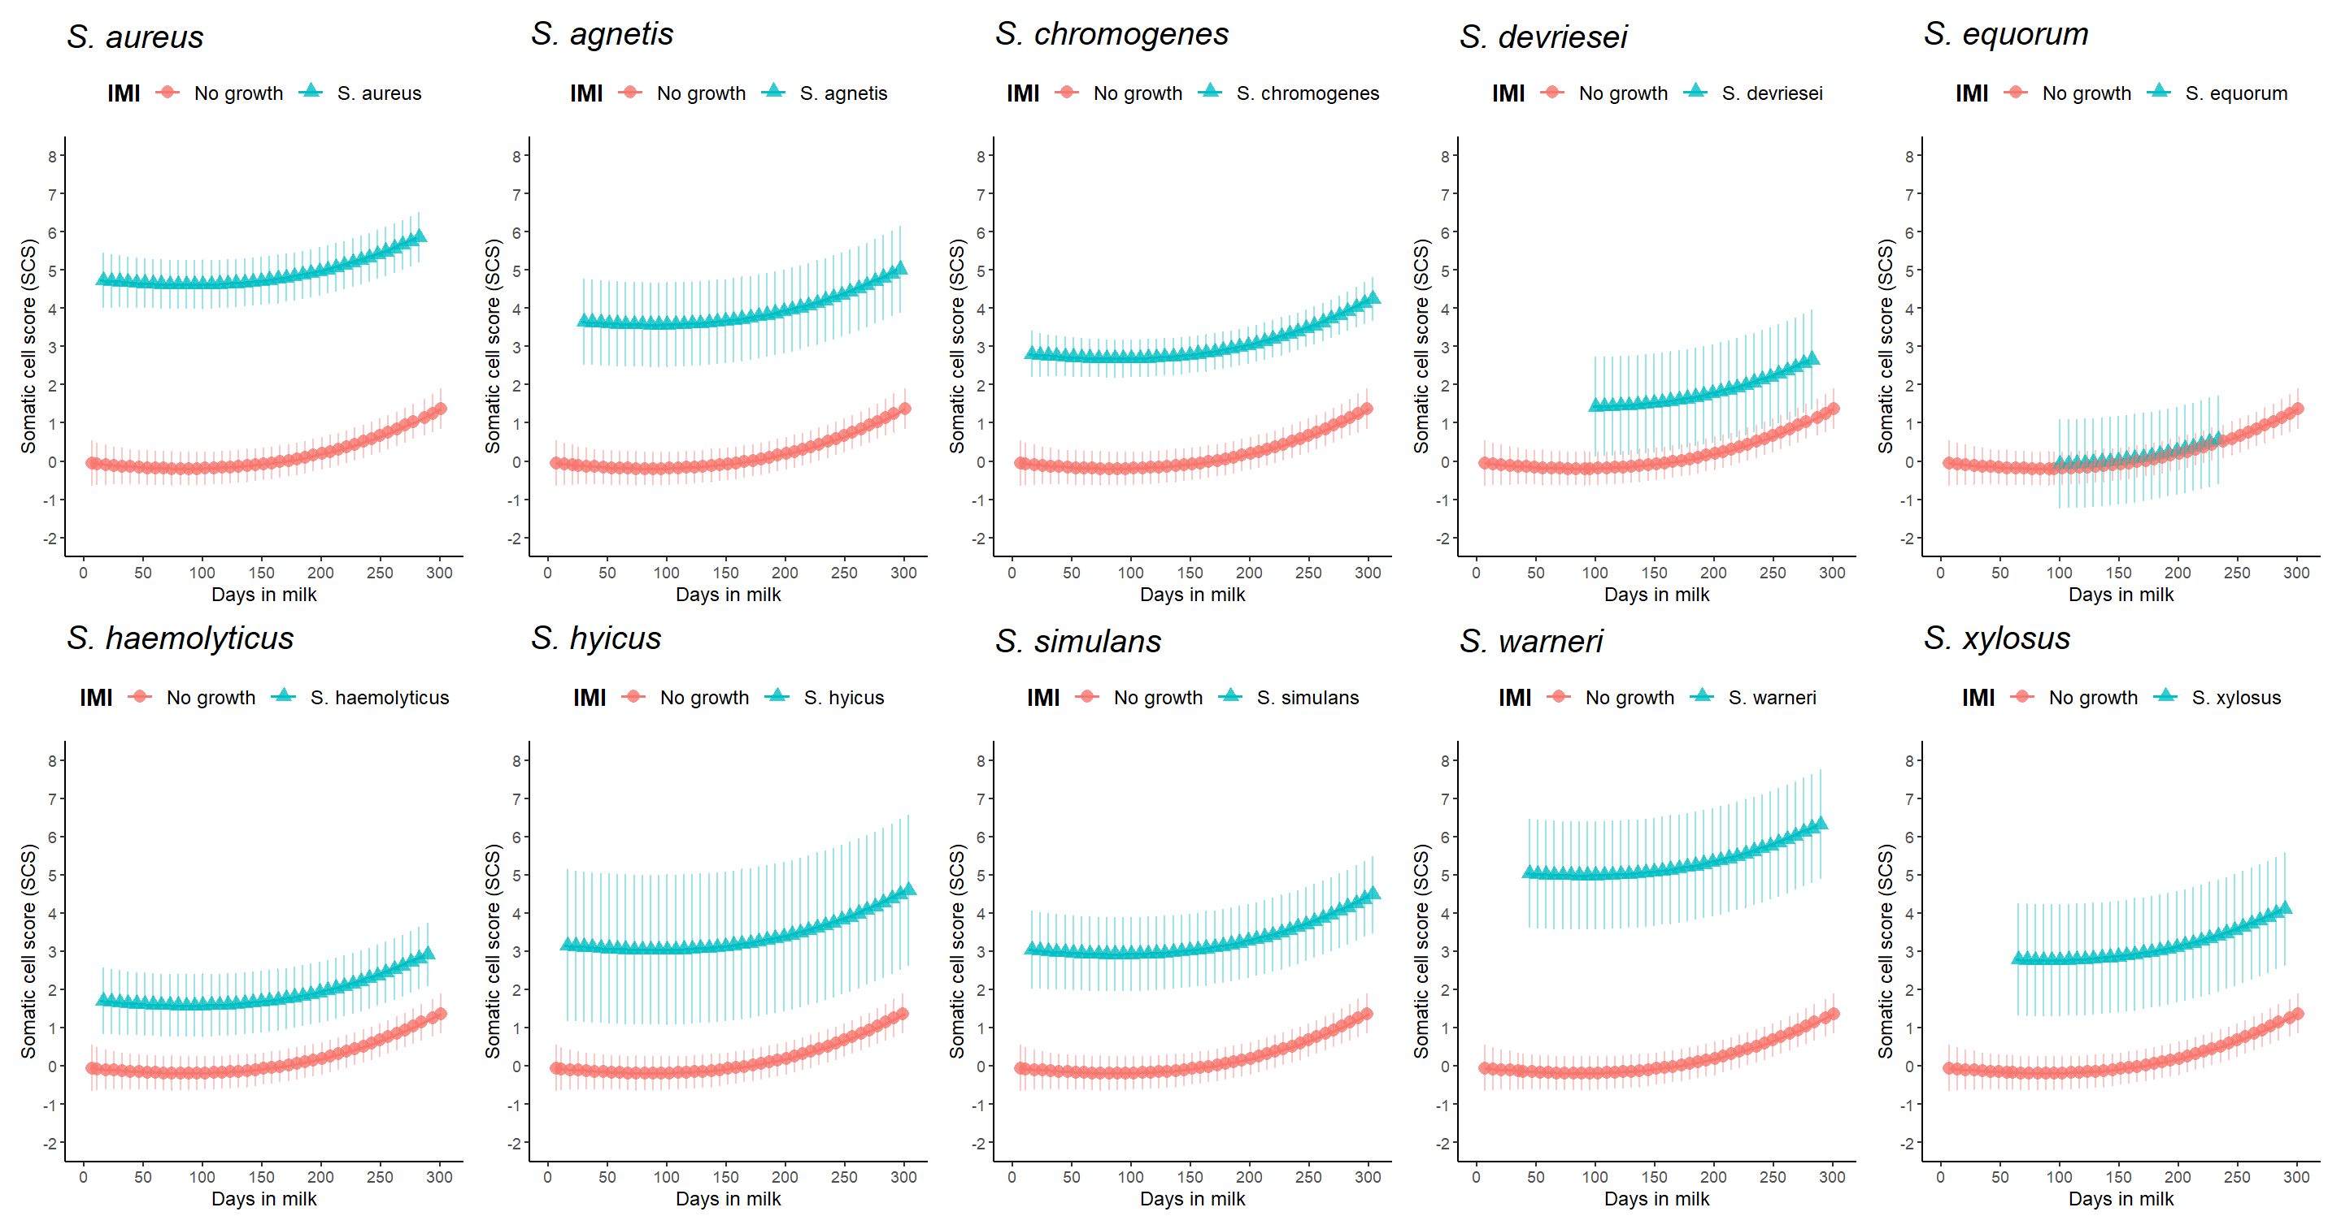

Figure XX. Quarter somatic cell score least square means estimates as a function of *Staph.* species IMI and days in milk, compared to culture negative quarters. Model estimates for each species are only presented for the range of days in milk found in the actual data set. Error bars represent the 95% confidence interval. [Is this true?]

Maybe don’t need legend with counts, if that’s in other table

Is this redundant in a way with the combined plot?

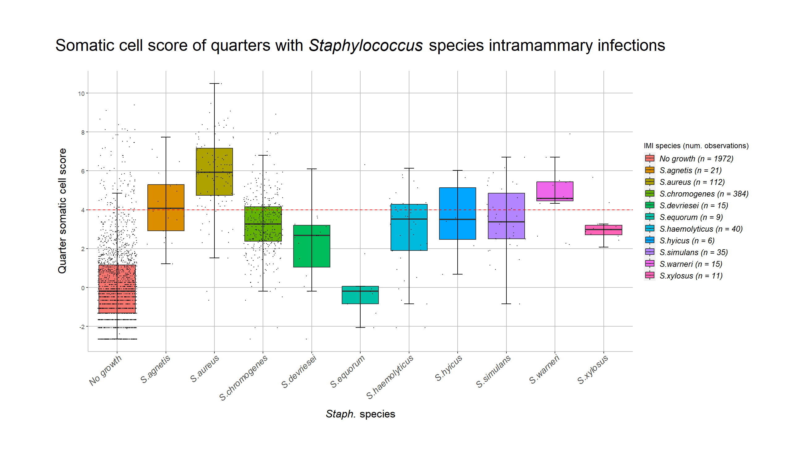

Adkins, P. R. F., S. Dufour, J. N. Spain, M. J. Calcutt, T. J. Reilly, G. C. Stewart, and J. R. Middleton. 2018. Molecular characterization of non-aureus Staphylococcus spp. from heifer intramammary infections and body sites. J. Dairy Sci. 101(6):5388-5403.

Adkins, P. R. F., J. R. Middleton, L. K. Fox, G. Pighetti, C. Petersson-Wolfe, and N. M. Council. 2017. Laboratory Handbook on Bovine Mastitis. National Mastitis Council.

Adkins, P. R. F., L. M. Placheta, M. R. Borchers, J. M. Bewley, and J. R. Middleton. 2022. Distribution of staphylococcal and mammaliicoccal species from compost-bedded pack or sand-bedded freestall dairy farms. J Dairy Sci 105(7):6261-6270.

Cameron, M., H. W. Barkema, J. De Buck, S. De Vliegher, M. Chaffer, J. Lewis, and G. P. Keefe. 2017. Identification of bovine-associated coagulase-negative staphylococci by matrix-assisted laser desorption/ionization time-of-flight mass spectrometry using a direct transfer protocol. J. Dairy Sci. 100(3):2137-2147.

Dohoo, I., S. Andersen, R. Dingwell, K. Hand, D. Kelton, K. Leslie, Y. Schukken, and S. Godden. 2011. Diagnosing intramammary infections: Comparison of multiple versus single quarter milk samples for the identification of intramammary infections in lactating dairy cows. J. Dairy Sci. 94(11):5515-5522.

Hwang, S. M., M. S. Kim, K. U. Park, J. Song, and E. C. Kim. 2011. Tuf gene sequence analysis has greater discriminatory power than 16S rRNA sequence analysis in identification of clinical isolates of coagulase-negative staphylococci. J Clin Microbiol 49(12):4142-4149.